**Amazon integration**

1. Login your aws.amazon.com login creditionals
2. First create your instance (it’s a virtual machine)
3. Click on **compute->EC2->launch instance->Amazon Linux AMI (optional any one select )**
4. Click next and next
5. At the end click launch pop up open
6. Create a new key pair **(public and private key ssh )**
7. Download keypair file
8. Now your instanace is create

Now connect your instance

Select your instance and click connect on the top

Create a folder on desktop and paste keypaire file there

And open git bash type **ssh -i "awakeel.pem"** [**ec2-user@54.186.149.205**](mailto:ec2-user@54.186.149.205)

**Commeand Copy this command from connect.**

**Note: ls is used for list directionry**

**now install nodejs**

**I follow this link to install nodejs**

[**http://iconof.com/blog/how-to-install-setup-node-js-on-amazon-aws-ec2-complete-guide/**](http://iconof.com/blog/how-to-install-setup-node-js-on-amazon-aws-ec2-complete-guide/)

type command

* sudo yum update
* sudo yum install gcc-c++ make
* sudo yum install openssl-devel
* sudo yum install git
* git clone git://github.com/joyent/node.git
* cd node

now check node is install type node

if it give a error command not found

now you install a node go to git bash and type

* ./config
* make
* sudo make install

and now install vu editor type

* sudo su
* vi etc/sudoers

**Note**: type **INSERT** button is using for editing a file and **ESC** used for edition done and **:wq**

for saving a file

* Use down keyboard arrow to find this line

Defaults secure_path = /sbin:/bin:/usr/sbin:/usr/bin

* Use the right arrow to move the cursor to the end of the line and press the INSERT button. Now type

:/usr/local/bin

Type exit and exit from su user

Now install npm

* git clone <https://github.com/isaacs/npm.git>
* cd npm
* sudo make install

**FTP UPLOAD FILES IN AMAZON**

1. **click ec2->open instance or select your instance check your instance security group (horizontal scroll right to left at the end there is a Colum security group) e.g. my case l**[**aunch-wizard-3**](https://us-west-2.console.aws.amazon.com/ec2/v2/home?region=us-west-2#SecurityGroups:search=sg-0e97356a;sort=groupId)
2. **go to network and groups->security groups and select your security group name in my case l**[**aunch-wizard-3**](https://us-west-2.console.aws.amazon.com/ec2/v2/home?region=us-west-2#SecurityGroups:search=sg-0e97356a;sort=groupId)
3. **and click on enbound and click edit a popup open click add rule and select custom tcp rule and give him port 21-22 or etc. and click save**
4. **OPEN file-zilla - > edit - >settings->sftp**
5. **Add keypaire pem file and it give you a ppk file save this file**
6. **And now open directory you can upload files there**

**How to install mysql in ec2 amazon**

**Login your creditonals with cmd**

**And type**

sudo yum install mysql-server

**Now type**

1. **service mysqld start**

**this is locally install in your instance only if u install on separately you can use**

**services->databases->RDS CLICK**

**click LAUNCH DB INSTANCE and complete wizard**

**amazon database backup**

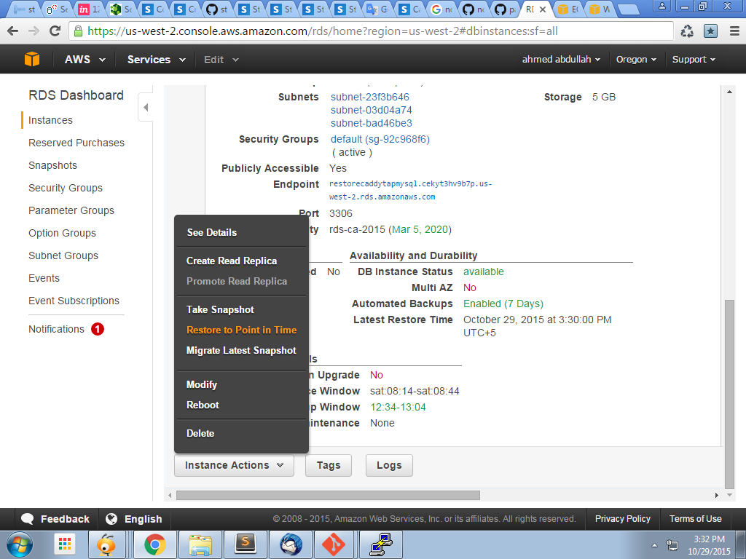

**When u click this auto backup restore.**

**______________________________________________**

**Updated on 11/16/2015**

**Sudo –I (root login)**

**If phpmdmin not working then check is your http port is configure**

**And must make rds instance for goto services->rds->click on launch db instance**

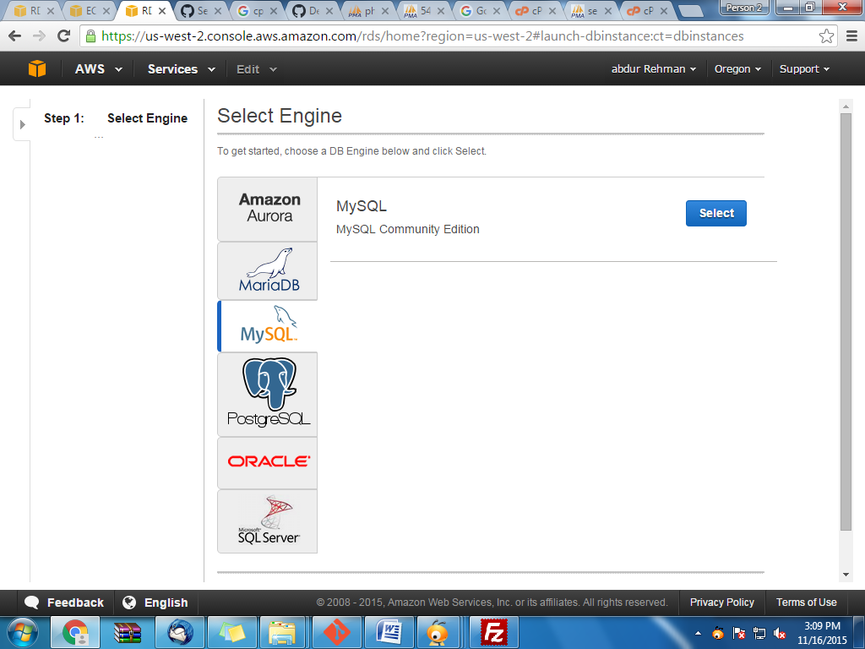

**Select any of them and**

**Get your end point it help your configure phpmyadmin**

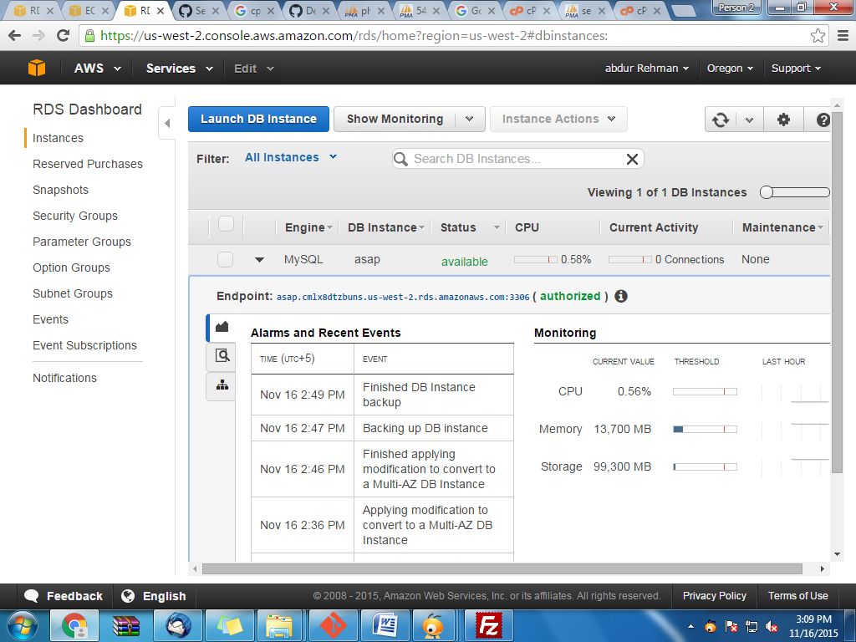

**Give custom ip to**

[**https://gist.github.com/shahzadthathal/cd01356ea983d5ea5932**](https://gist.github.com/shahzadthathal/cd01356ea983d5ea5932)

**Create ftp**

sudo yum install vsftpd

[**http://stackoverflow.com/questions/7052875/setting-up-ftp-on-amazon-cloud-server**](http://stackoverflow.com/questions/7052875/setting-up-ftp-on-amazon-cloud-server)

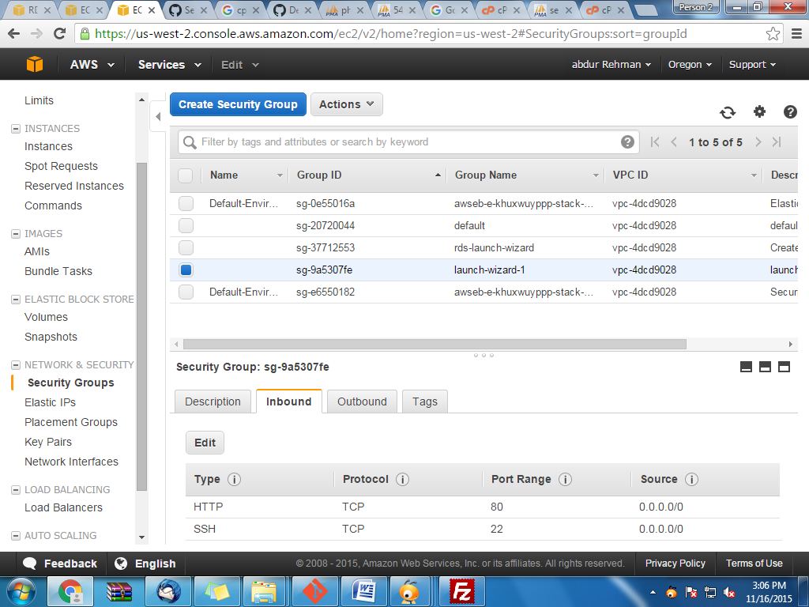

**Mount data is used for show directory in other user**

Mount a directory to users folder

mount --bind var/www/html home/ec2-user/website

Cron job on ec2 amazon

First type

Crontab –e

And then press insert button

Write this code

Minute | hours | month | days | weekend

+---------------- minute (0 - 59)

| +------------- hour (0 - 23)

| | +---------- day of month (1 - 31)

| | | +------- month (1 - 12)

| | | | +---- day of week (0 - 6) (Sunday=0 or 7)

| | | | |

* * * * * command to be executed

* * * * * php /var/www/html/WestChesterRideCorp/admin/crontest.php

And press escape

And write :wq

Git ssl error command

git config --global http.sslVerify false

Create image of instance

Select instance ->actions->image->create image

and give

Image name and description and click create image

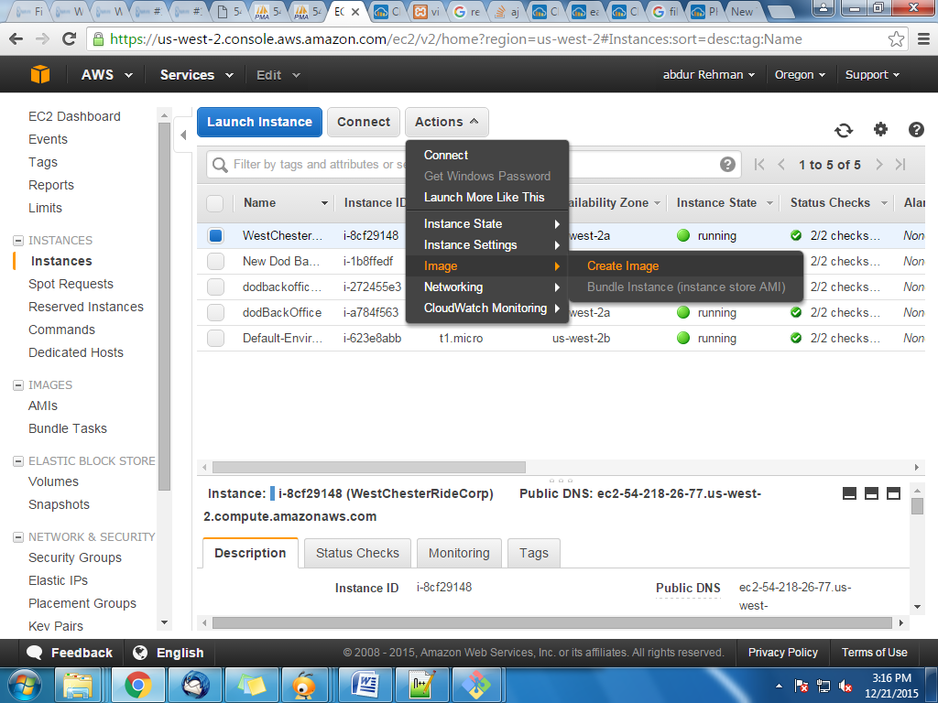

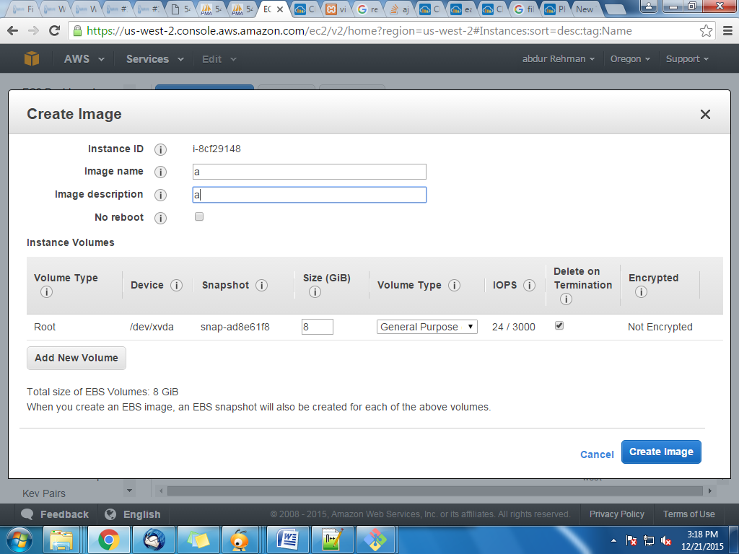

Launching instance

Images->AMI’S

SELECT your instance and click launch

And start your services and select that security group which is previously created.

Static or elastic ip

When instance create it virtual ip assign when instance is destroy then ip also dry then problem is occur. For solution of this problem is creating elastic Ip or static ip.

Networks and security->elastic ips

Click allocate new address

And select that ip and click actions->Associate address

And then give instance which you want to associate that ip and click associate

